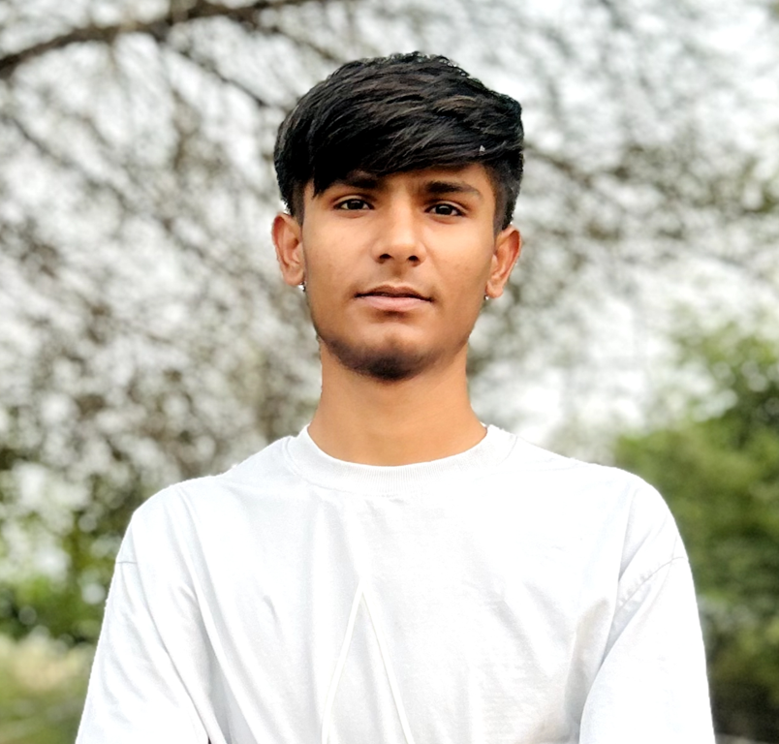

🌟 Yash: A Healing Dream in the Making
Yash always dreamed of a career in healthcare, driven by a strong desire to serve society. But financial challenges stood in the way of pursuing his passion.
With the support of Utsav Foundation, Yash enrolled in the D.Pharma course at Om Sterling Global University. Today, he is thriving in his studies and is committed to becoming a skilled pharmacist.
His journey is a powerful reminder that purpose-driven support can turn aspirations into reality and empower youth to give back to the community.

